xpedx.com Next Generation
Technical Design Specification – Rule Engine

Authors: | Sterling Commerce
Version: | 0.1
Date Created: | 5/11/2010
Last Updated:

Document Revision History
Revision | Date | Description | Author
0.1 | 05/11/2010 | Draft | Sterling Commerce

Document Approval History
Name | Signature | Date | Version Approved/Comments

Reference Documents
Document Name | Description | Owner | Location
SCI_Xpedx Solution Definition Document v1.0 | Solution Definition document | Sterling Commerce

Table of Contents
2. UI ref to HLD, if HLD has the UI details. 4
2.2.1 Design for XPXGetOrderDetailsWithRuleValidation 4
2.2.1.1 UI Design 4
2.2.1.2 UI Validations 4
2.2.1.3 Input Document 5
2.2.1.4 Output Document 5
2.2.1.5 Configuration 5
2.2.1.6 <Insert Sub-Component Name> 13
3. Database Extensions 13
4. Exception and Error Handling 14
5. Security Aspects 14
5.1 Ownership 14
5.2 Encryption 14
5.3 Audit Trail 14
5.4 Other Security Aspects 14
6. Dependencies 14
7. Unit Test Cases 15
7.1 <Insert Component Name> 15

Introduction

Purpose
- XReference Section 1.1 – Document Purpose in Functional Design Document

2. UI ref to HLD, if HLD has the UI details.

1.2 Nomenclature
<Glossary of terms - list only new terms applicable to this design>

1.3 Performance Considerations
List of all the factors that impact performance

2. Technical Components

2.1 Components Overview

This Rule engine component will validate the order for customer profile, and put order on hold.

2.1.2 Component Design

- XPXGetOrderDetailsWithRuleValidation

2.1.2.1 Design for XPXGetOrderDetailsService

This component takes the OrderHeaderKey and OrganizationCode as the input. This input will be required to fetch the order details, Order details will be validated against customer profile Rules. If error found order will be put on new hold (NEEDS_ATTENTION).
2.1.2.1.1 UI Design
<This section is applicable to UI components. Provide a UI mockup and elaborate the design for UI>N/A

2.1.2.1.2 UI Validations
<This section is applicable to UI components. Provide the various validations that need to be applied for each field/control on the UI mock-up>N/A

2.1.2.1.3 Input Document

<Order EnterpriseCode="" OrderHeaderKey="" >

2.1.2.1.4 Output Document

<Order OrderNo="" …..>
<Error ShipDateErrorText="Ship Date should be atleast 2 days after the Ordered Date." …../>
….
<OrderLines>
<OrderLine PrimeLineNo="" ….>
<Error ItemIDErrorText="Invalid Item. " …../>
….
</OrderLine>
</OrderLines>
</Order>

2.1.2.1.5 Configuration
Create service XPXGetOrderDetailsService

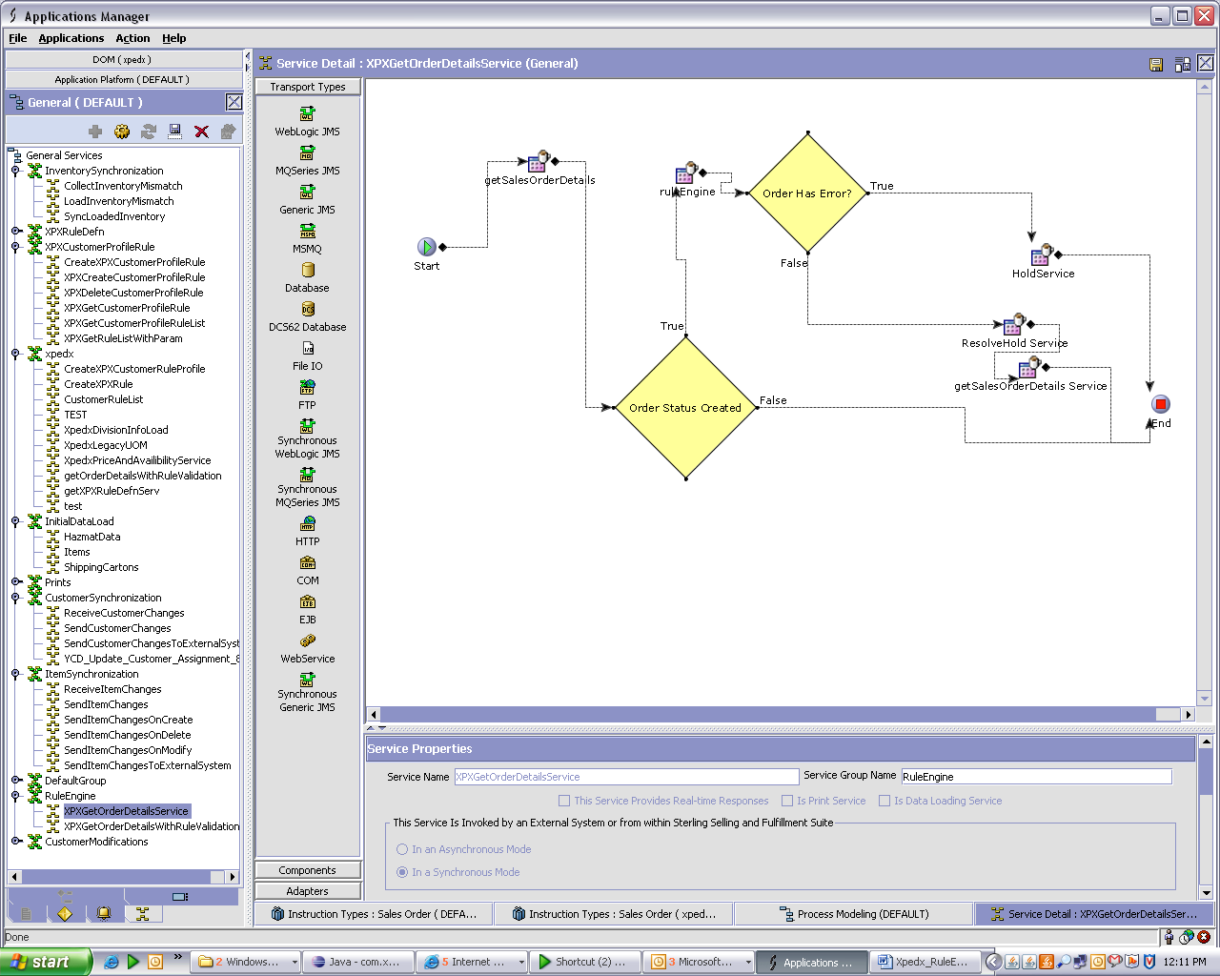

Properties: API

Standard API
API Name :- getSalesOrderDetails
Template:- global/template/api/getSalesOrderDetails.XPXGetOrderDetailsService.xml

Condition:-
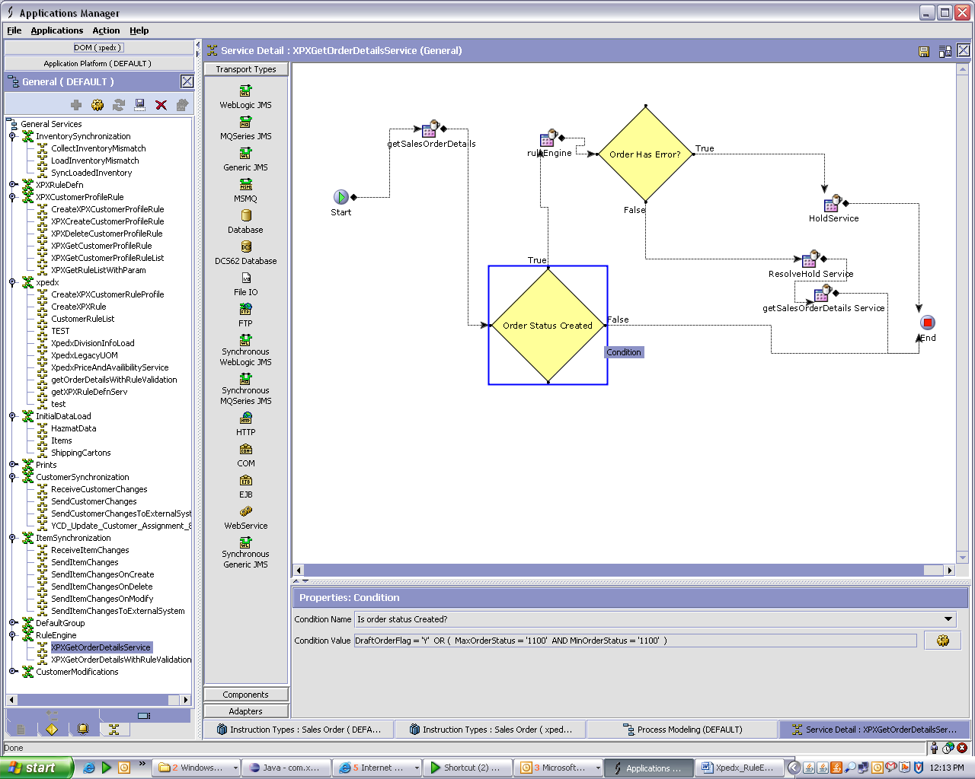

Condition Name = Is order status Created??
Condition Value = DraftOrderFlag Is 'Y' OR ( MaxOrderStatus Is '1100' AND MinOrderStatus Is '1100' )

API Properties:
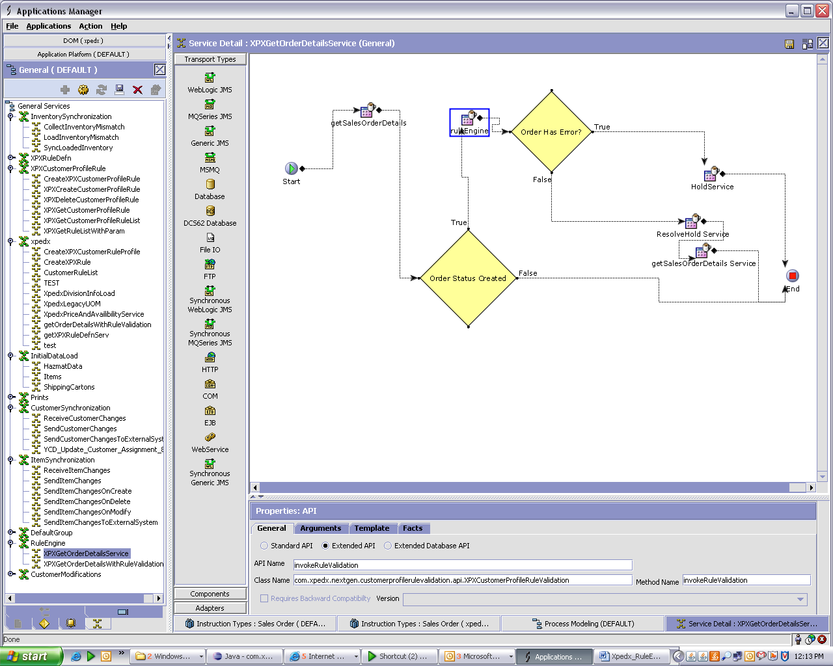

Extended API
API Name :- invokeRuleValidation
Class Name:- com.xpedx.nextgen.customerprofilerulevalidation.api.XPXCustomerProfileRuleValidation
Method Name:- invokeRuleValidation

Condition Properties:-
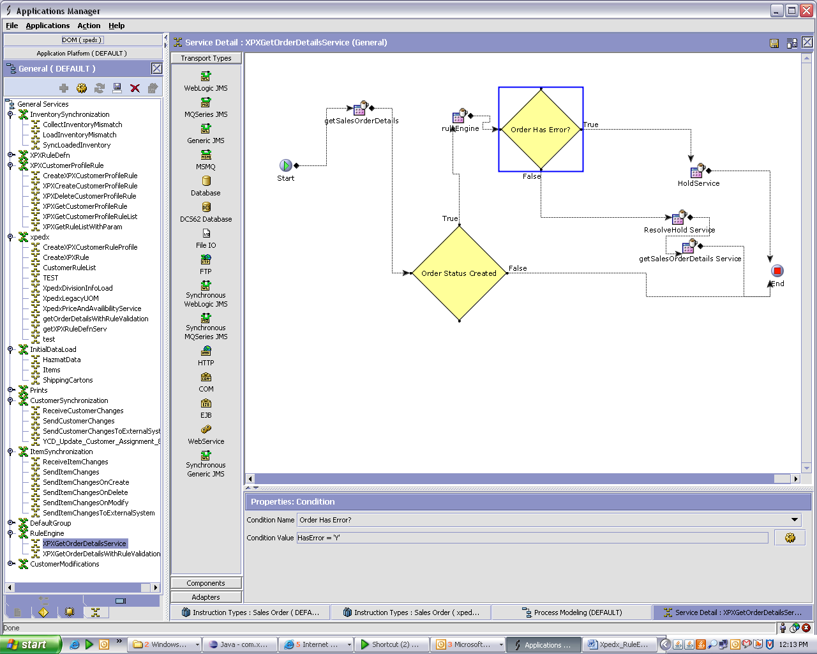

Condition Name = Order Has Error?
Condition Value = HasError is ‘Y’

API Properties:-

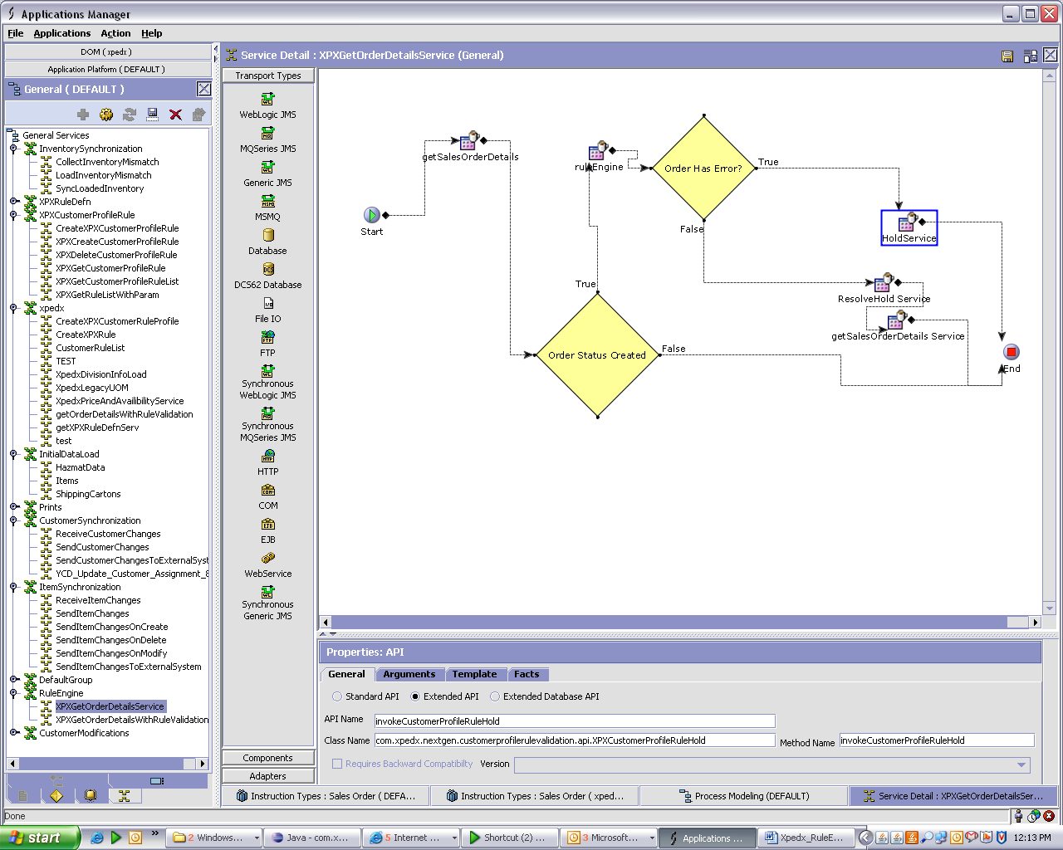

Extended API
API Name :- invokeCustomerProfileRuleHold
Class Name:- com.xpedx.nextgen.customerprofilerulevalidation.api.XPXCustomerProfileRuleHold
Method Name:- invokeCustomerProfileRuleHold

API Properties:-
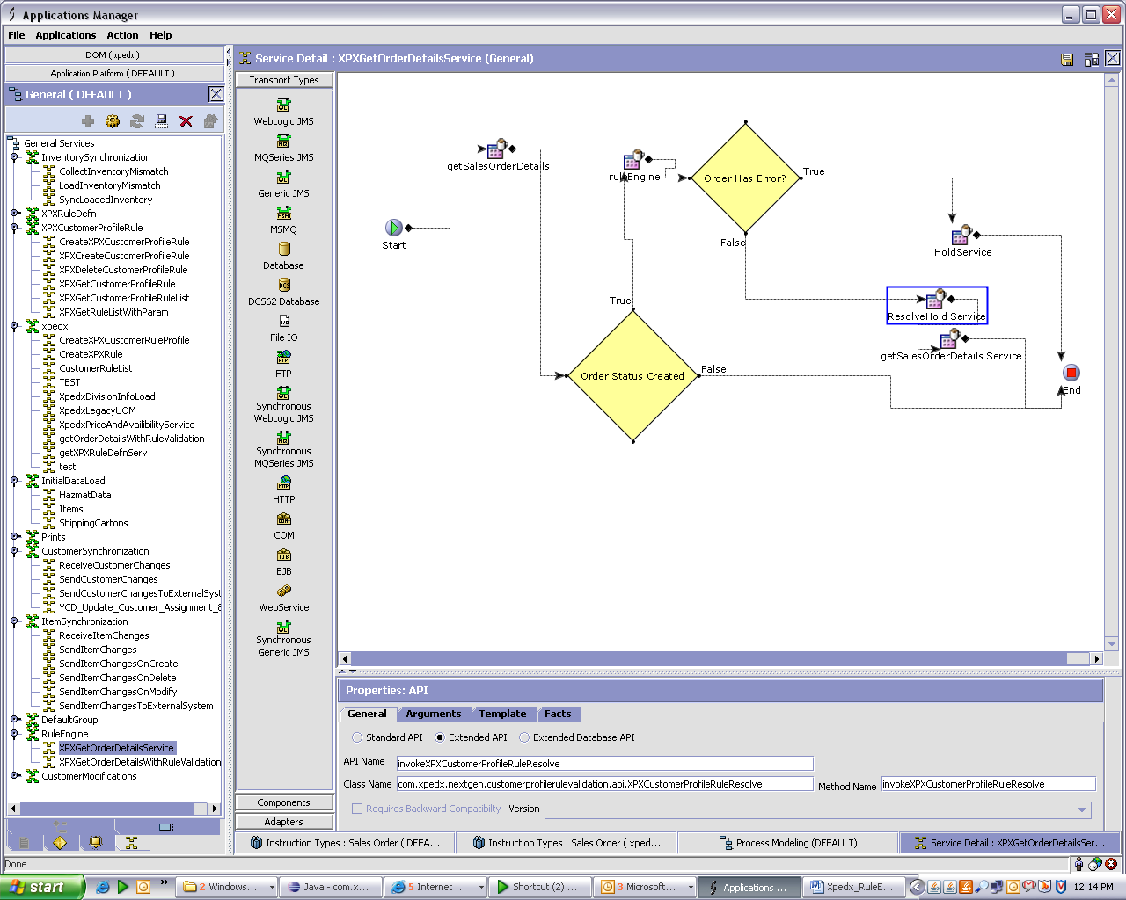

Extended API
API Name :- invokeXPXCustomerProfileRuleResolve
Class Name:- com.xpedx.nextgen.customerprofilerulevalidation.api.XPXCustomerProfileRuleResolve
Method Name:- invokeXPXCustomerProfileRuleResolve

API Properties:-
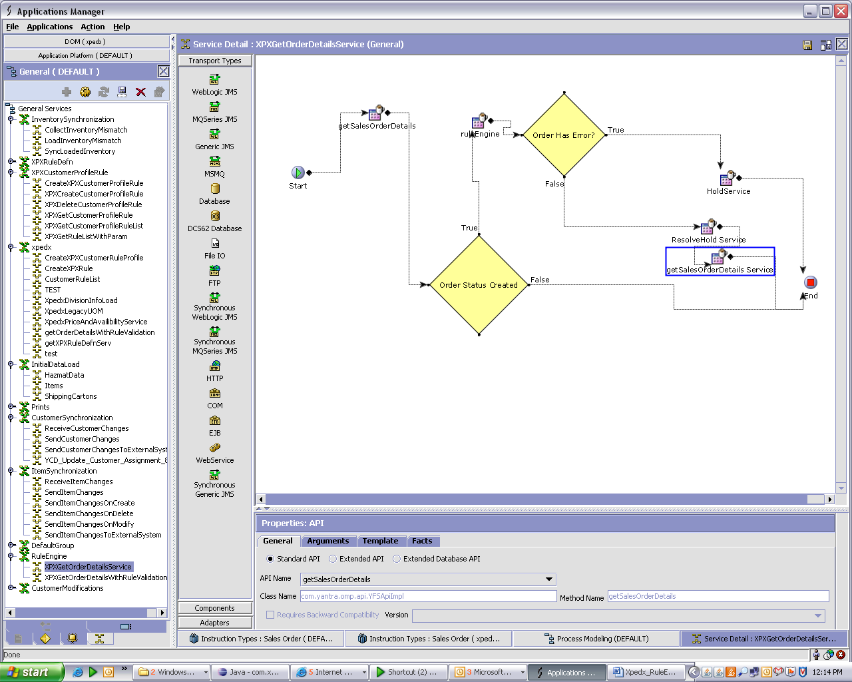

Standard API
API Name :- getSalesOrderDetails
Template Name:- global/template/api/getSalesOrderDetails.XPXGetOrderDetailsService.xml

Custom Common Code
Create Custom Common Code Types
Code=XPXRuleID
Short Description= RuleID
Long Description = Error Message
Set Custom Common codes for organization xpedx
Add RuleID= RuleID (e.g. DuplicatePO)
Short Message = Error Message needs to be shown to user (e.g. Do not allow duplicate Pos)
Long Message = Error Message needs to be shown to user (e.g. Do not allow duplicate Pos)

Hold Types
Go to Distributed Order Management -> Document Specific->Fullfillment-> Hold Types
Add new Hold Type
Hold Type = NEEDS_ATTENTION
Hold Type Description= NEEDS ATTENTION

2.1.2.1.6 XPXCreateRuleDefn
Creates record in XPX_RULE_DEFN
- Input Document
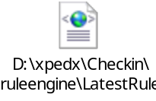
- Output Document
<XPXRuleDefn RuleDesc=" " RuleGroup="" RuleID=" " RuleKey="" RuleLongDesc=" "/>

Configuration:-
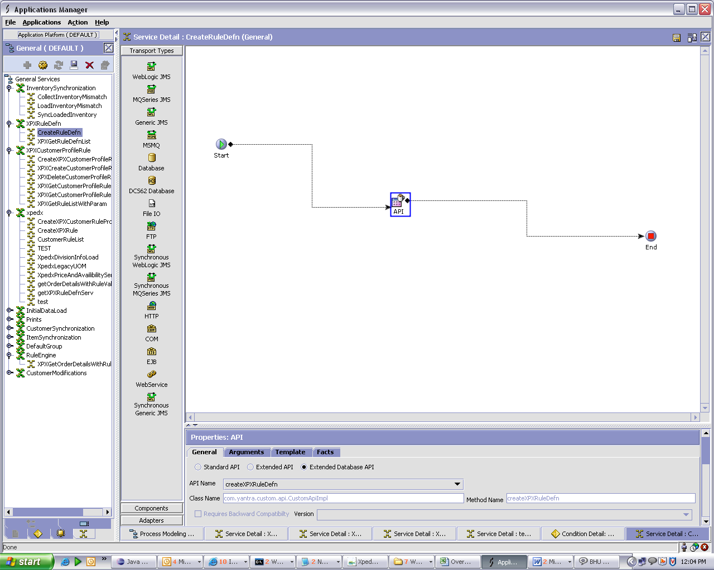

API Properties:-
Extended Database API
API Name-createXPXRuleDefn

2.1.2.1.7 XPXGetRuleDefnList
Gets records from XPX_RULE_DEFN
- Input Document
<XPXRuleDefn/>
- Output Document
<XPXRuleDefnList>
<XPXRuleDefn RuleDesc=" " RuleGroup="" RuleID=" " RuleKey="" RuleLongDesc=" "/>
</XPXRuleDefnList>

Configuration:-
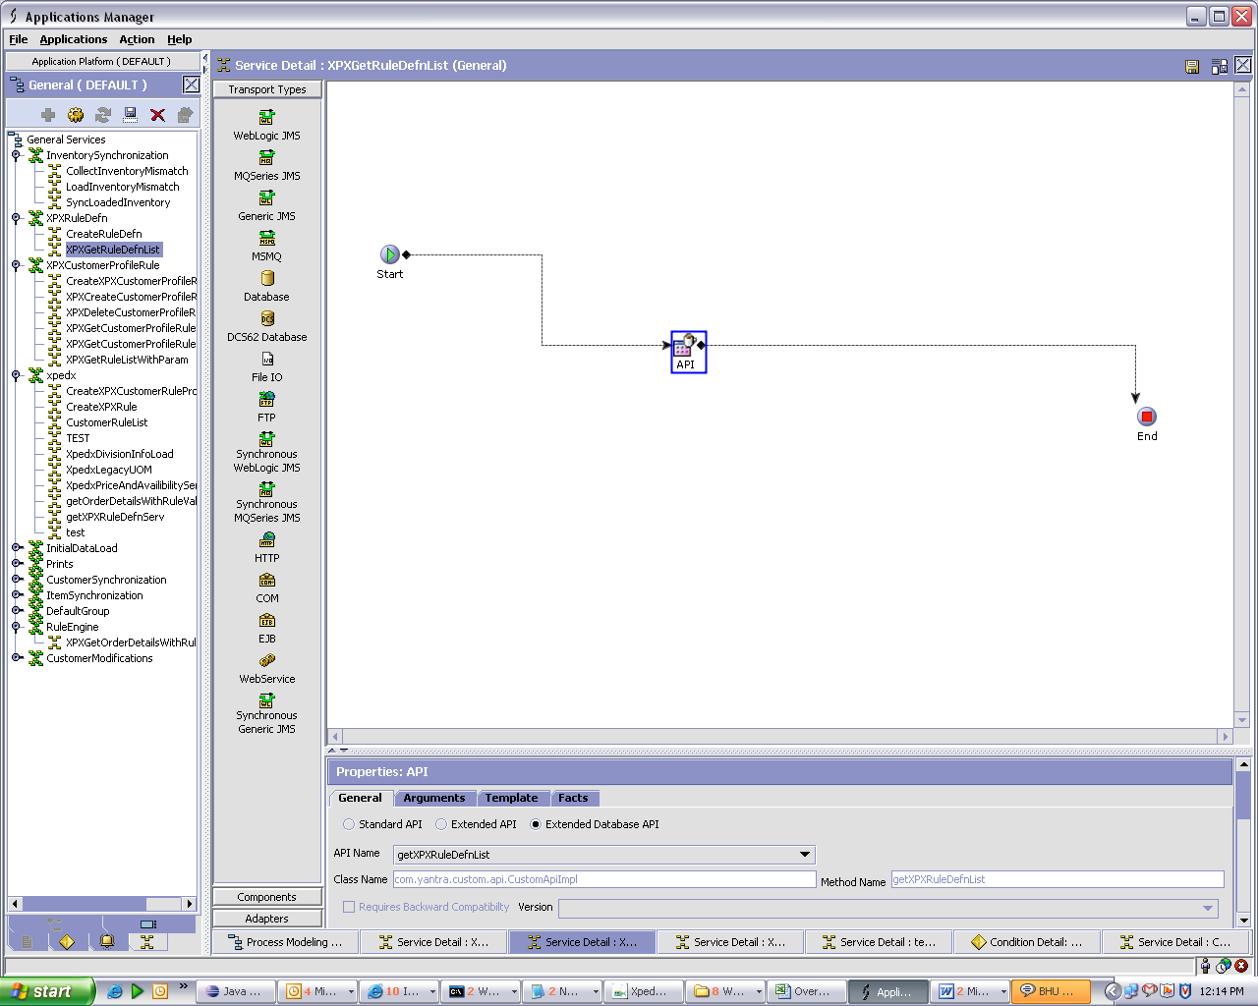

API Properties:-
Extended Database API
API Name-getXPXRuleDefnList

2.1.2.1.8 XPXCreateCustomerProfileRule
Create record in XPX_CUSTOMER_RULES_PROFILE
- Input Document
<XPXCustomerRulesProfile CustomerID=" " CustomerKey="" OrganizationCode=" " RuleKey=""/>
- Output Document
<XPXCustomerRulesProfile CustomerID=" " CustomerKey="" OrganizationCode=" " RuleKey=""/>

Configuration:-
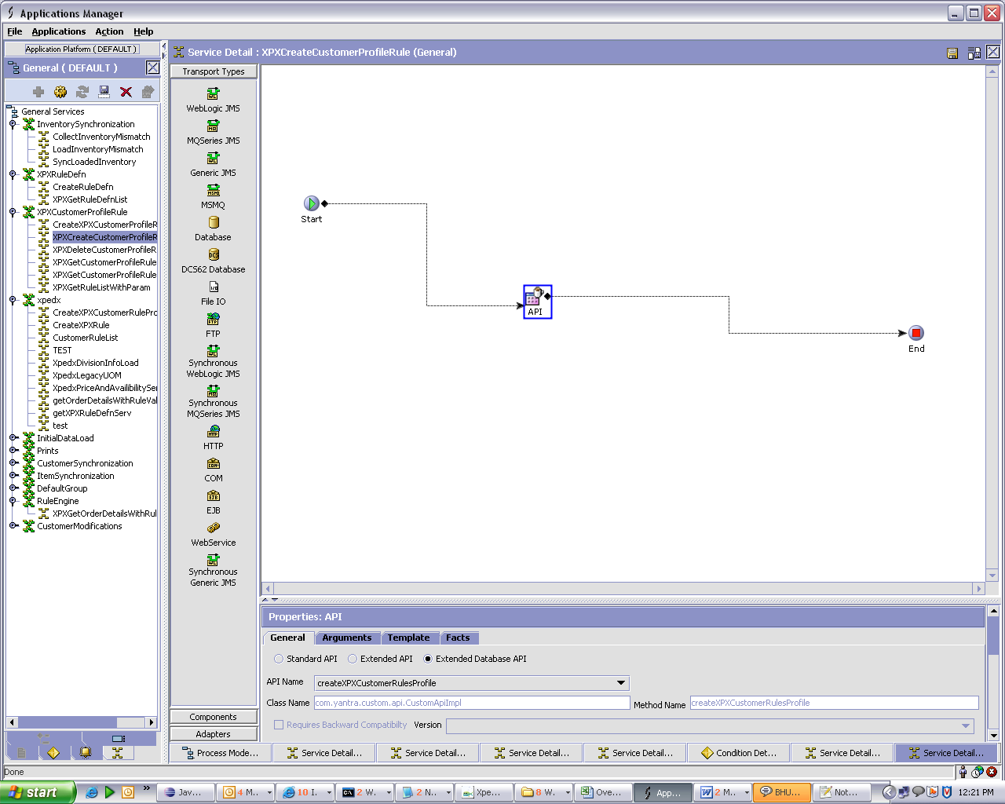

API Properties:-
Extended Database API
API Name-createXPXCustomerRulesProfile

2.1.2.1.8 XPXGetCustomerProfileRuleList
Gets record from XPX_CUSTOMER_RULES_PROFILE
- Input Document
<XPXCustomerRulesProfile CustomerKey="" />
- Output Document
<XPXCustomerRulesProfileList>
<XPXCustomerRulesProfile CustomerID=" " CustomerKey="" OrganizationCode=" " RuleKey=""/>
</XPXCustomerRulesProfileList>

Configuration:-
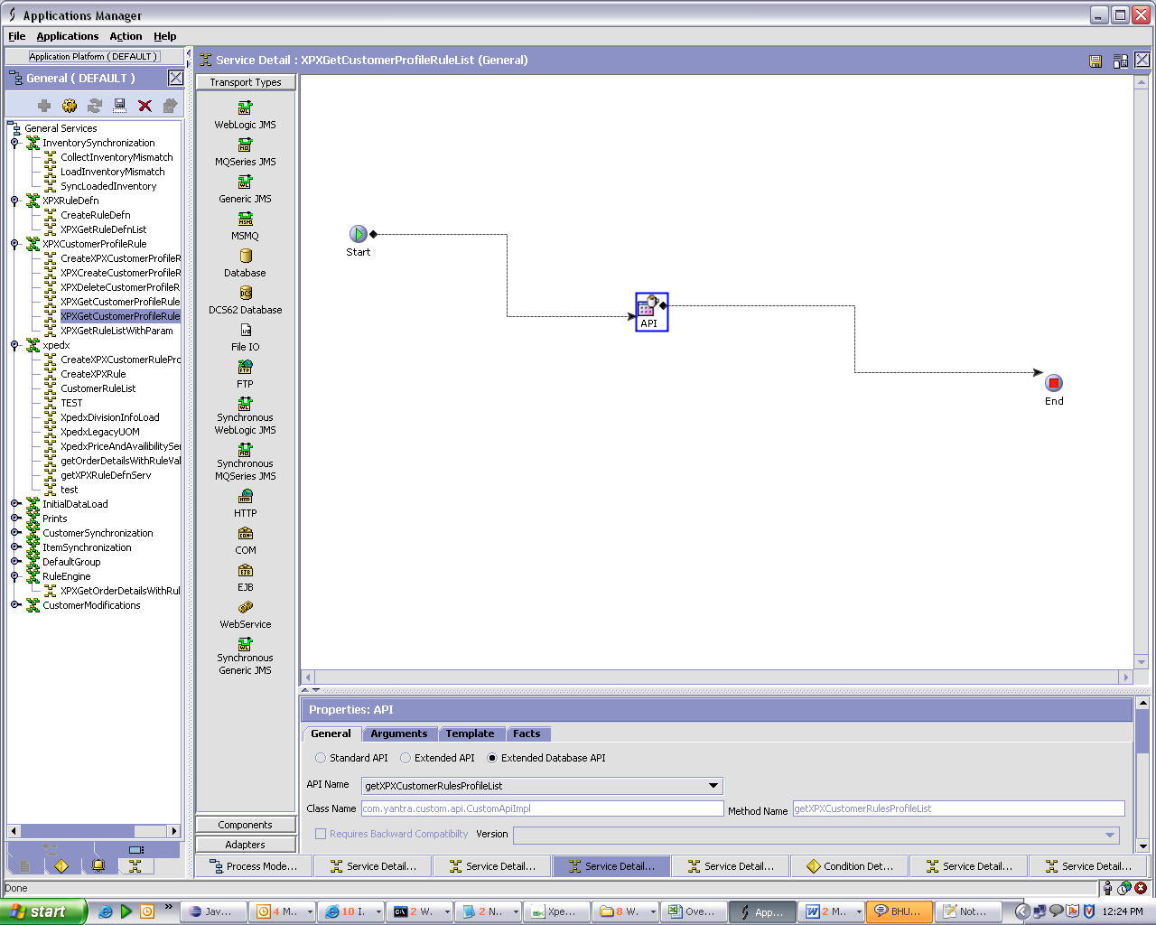

API Properties:-
Extended Database API
API Name-getXPXCustomerRulesProfileList

3. Database Extensions
<Provide the database extensions required for the component in the format provided below. The data types need to be clearly specified. Always Out-of-the-box data types should be reused. If a data type for the given combination doesn’t exist, a new data type name should be specified>

<Database Extension Template>
Table Name |  | XPX_RULE_DEFN
Overview |  | Xpedx Rule Definition
Extensions/Custom/Hang-off |  | Custom
Primary Keys |  | RULE_KEY
Index on
Attribute Name | Column Name | Data Type/Size | OOB Data Type Name | Default Value | Description
RuleKey | RULE_KEY |  | Key | ‘ ‘ | Rule Key
RuleID | RULE_ID |  | RuleType-50 | ‘ ’ | Rule ID
RuleDesc | RULE_DESC |  | CodeShortDescription |  | Description
RuleLongDesc | RULE_LONG_DESC |  | LongDescription |  | Long Description
RuleGroup | RULE_GROUP |  | Text-2 |  | Values a are GR- General Rule, OR- Order Rule, LR- Line rule.
B2BFlag | B2B_FLAG |  | Text-1 |  | EDI Specific
InteractiveFlag | INTERACTIVE_FLAG |  | Text-1 |  | Non EDI Specific

Table Name |  | XPX_CUSTOMER_RULES_PROFILE
Overview |  | XPedx Customer Rules Profile
Extensions/Custom/Hang-off |  | Hang-Off
Primary Keys |  | CUSTOMER_RULES_PROFILE_KEY
Index on
Attribute Name | Column Name | Data Type/Size | OOB Data Type Name | Default Value | Description
CustomerRuleProfileKey | CUSTOMER_RULES_PROFILE_KEY |  | Key | ‘ ‘ | Customer Rule Profile Key
CustomerKey | CUSTOMER_KEY |  | Key |  | Customer Key(Foreign key YFS_CUSTOMER)
RuleKey | RULE_KEY |  | Key |  | Rule Key(Foreign key XPX_RULE_DEFN)
CustomerID | CUSTOMER_ID |  | CustomerId |  | Customer ID
OrganizationCode | ORGANIZATION_CODE |  | OrgCode |  | Organization code
Param1 | PARAM1 |  | Parameter |  | Parameter
Param2 | PARAM2 |  | Parameter |  | Parameter
Param3 | PARAM3 |  | Parameter |  | Parameter

4. Exception and Error Handling

5. Security Aspects
<Provide details on the security aspects of this implementation. Where would these security components reside, what will be encryption that will be used and any audit trails required>N/A

5.1 Ownership
5.2 Encryption
5.3 Audit Trail
5.4 Other Security Aspects

6. Dependencies
<For issues that are dependent on customer: Record all dependencies made for this design including business requirement, performance and technical factors, etc. in JIRA and list the JIRA tickets numbers here

JIRA no | desc | To be validated by  (Team/Person) | Status | Implications if incorrect

<For issues those aren’t dependent on customer: Record all dependencies made for this design including business requirement,performance and technical factors, etc. here

Include only those that are not already documented in SDD If there are changes in SDD, reference the specific dependency and state the revised assumption. New assumption should be approved prior to design review> XReference Section 2.8 – Assumptions in Functional Design Document.

No. | Assumption | To be validated by  (Team/Person) | Status | Implications if incorrect

7. Unit Test Cases
<Elaborate unit test cases for all the components. Every unit test case should include description, pre-requisites, expected results, etc. The below section should repeat for each component>

7.1 <Insert Component Name>

Test No. | Test Description | Execution Instructions | Expected Result
1 | Give the OrderHeaderKey and Organization code as the input to this service, Order should not be in Created status. |  | Customer Profile Rule engine will not be called.
2 | Give the OrderHeaderKey and Organization code as the input to this service, Order should be in Created status. Customer has no rules setup. |  | No error should be thrown in output order XML
3 | Give the OrderHeaderKey and Organization code as the input to this service, Order should be in Created status. Customer has some rules setup. |  | Rule engine will be called and error element will be added in order XML in case of any validation fail.  Order will be put on Hold
4 | Give the OrderHeaderKey and Organization code as the input to this service, Order should be in Created status. Customer’s parent has some rules setup. |  | Rule engine will be called and error element will be added in order XML in case of any validation fail.  Order will be put on Hold
5 | Give the OrderHeaderKey and Organization code as the input to this service, Order should be in Created status. Customer has some rules setup. And errors have been over ridden. |  | Order hold will be resolved and error element will not be shown in order XML.

Appendix:-

Rule Definition

RuleID | RuleDesc | RuleLongDesc | RuleGroup
AcceptPriceOverRide | Accept price override | Order line specifies a price which is different from that returned by the Price and Availibilty | GR
PreventAutoPlace | Prevent orders from being auto placed | Prevent orders from being placed automatically on ordering system. | GR
HeaderCommentByCustomer | Header comments were sent by customer | Header comments were sent by customer | OR
DuplicatePO | Do not allow duplicate Pos | Do not allow duplicate Pos | OR
NonStandardShipMethod | Non-Standard ship method | Non-Standard ship method | OR
CustomerSelectedShipComplete | Customer selected ship complete | Customer selected ship complete | OR
ValidShiptoZipCode | Validate ship-to zip code | Validate ship-to zip code | OR
ShipDateNotNextBusinessDay | Ship date not next business day | Ship date not next business day | OR
IncorrectETradingID | Incorrect eTrading ID | Incorrect eTrading ID | OR
LineCommentsByCustomer | Line comments were sent by customer | Line comments were sent by customer | LR
RequiredCustomerLinePO | Require customer line PO | Require customer line PO | LR
RequireCustomerLineField1 | Require customer line field1 | Require customer line field1 | LR
RequireCustomerLineField2 | Require customer line field2 | Require customer line field2 | LR
RequireCustomerLineField3 | Require customer line field3 | Require customer line field3 | LR
AllDeliveryDatesDoNotMatch | All Req Line DeliveryDates donot match | All Req Line DeliveryDates donot match | OR
PreventBackOrder | Prevent back orders | Prevent back orders | LR
ItemNotAvailableForNextDayShipment | Items not available for nextday shipment | Items not available for nextday shipment | LR
PriceDiscrepency | Price discrepancy | Price discrepancy | LR
RequiredCustomerLineSequenceNo | Require Customer Line Sequence Number | Require Customer Line Sequence Number | LR
RequiredCustomerLineAccountNo | Require Customer Line Account Number | Require Customer Line Account Number | LR

